Predicting NFL Run/Pass Decisions
  - Aditya Fuldeore

Abstract
This study applies data mining and statistical learning methods to the problem of predicting offensive play-type in the National Football League using pre-snap situational information. The ability to anticipate if an opponent's play call is a run or pass has direct implications for defensive game planning and offensive self-scouting. Using play-by-play data from the nflfastR ecosystem spanning the 2022 through 2025 NFL regular seasons, we construct a rich feature set of approximately 30 pre-snap variables. All models are trained on the 2022 through 2024 seasons and evaluated on the fully held-out 2025 season.
Four classification models are compared against a logistic regression baseline: Ridge logistic regression, Lasso logistic regression, K-Nearest Neighbors, and Principal Component Regression with a logistic link. Model selection for regularization parameters and the number of principal components is performed via five-fold cross-validation on the training data, with AUC as the primary evaluation metric. Results indicate that KNN performs well under AUC but all models have similar performances.
Beyond model performance, a team-level predictability ranking scores each offense by how accurately the model classifies their individual play calls on the test season, providing a data-driven measure of offensive tendency exploitation. Teams with high model accuracy are those whose play-calling is strongly determined by situational context. These represent potential defensive advantages, while those with low scores suggest strategic unpredictability. These findings demonstrate that machine learning approaches can formalize and quantify play-calling tendencies, with meaningful potential for usage in both defensive preparation and offensive play-calling design.

Introduction
Every offensive snap in the National Football League (NFL) begins with a binary decision to either run or pass. This choice is shaped by down, distance, score, time, and personnel, with tendencies that opposing defense attempt to adapt to. The main question of this project is whether those tendencies can be analyzed to predict if an offense is going to attempt a run or a pass.
There is both analytical and practical motivation for this project. From a football standpoint, predicting the likelihood of a run or pass gives defenses better game-planning ability, while offenses can see which of their tendencies are becoming predictable and in what scenarios a pass decision would have been better than a run, and vice versa. From a data mining standpoint, the problem offers a large dataset of NFL play-by-play data to analyze real-world actions with a binary outcome and the ability to compare classification approaches. The NFL has moved increasingly toward analytics-driven decision-making and play-call tendency modeling is an extension of it.
There will be challenges in data mining, such as balancing the binary decisions so a classifier isn’t always predicting the “pass”, which tends to be the play call more than 50% of the time. The features will need to be checked for multicollinearity while certain features may need transformations or interactions in order to be more accurate. Having good, clean data to model with, and narrowing down a modeling method between classification models, regularized models, and dimension reduction are some of the challenges involved.
In order to solve this problem, raw play-by-play data from the 2019-2025 NFL seasons was initially considered, but this was reduced to 2022-2025 data in order to save on lengthy run times. This data will first be loaded into R. Exploratory data analysis will be conducted before diving into feature engineering, and model comparisons will be made between Logistic, Ridge, Lasso, and Principal Component Regression. The learning aim from this project is to learn how accurately a run/pass decision can be predicted, if there are exploitable tendencies for NFL defenses to observe, and if certain feature measures indicate that it is better for an offense to pass or run in certain situations.

Problem Statement & Data
The problem statement of this project is: can a data-driven model predict whether a given play will be a run or pass using only information available before the snap, and which situational factors drive that prediction most strongly?
Concretely, when an offense faces a 3rd-and-8 from midfield, down by six points in the third quarter with the offense in shotgun formation and 11 personnel on the field, how confident can a model be that the next play will be a pass?
The primary data source will be the nflfastR play-by-play dataset, accessed via an R package. It provides clean and standardized play-level data for NFL regular seasons 1999 to present. There are 372 different variables in this data to indicate the different features and outcomes of an NFL play. Intuitively, only factors involved in the pre-snap decision of run or pass will be used. These are identifier variables to differentiate the record, the target variable of play type being run or pass, down and distance variables, field position, formation, game state, and weather/environment variables.
Also to be considered is personnel grouping data, available from the nflverse universe of R packages. This data can be loaded into R via the nflreadR package and contains information on the offensive formation, personnel, and defensive setup for a given play. A combination of these data sources can help choose the best features for this analysis.
First, the raw play-by-play data from the nflreadR dataset is filtered to include just regular season NFL plays that are rushes or passes. Intuitively, the data will include the following variables:
- Identifiers
  - Game ID, play ID, possession team, defending team, season, week, away team, home team
- Target variable
  - Play type: run or pass
- Down and Distance
  - Down, yards to go for first down, indicator for if it is a goal-to-go play
- Field position
  - Number of yards the team is from the opponent’s end zone
- Game state
  - Score differential, win probability, seconds left in the game, seconds left in the half, the quarter, timeouts remaining for each team
- Formation
  - Indicator if it is a shotgun formation, indicator if it is a no-huddle offense
- Environment
  - Roof indicator, temperature, wind, type of field surface
I will also add variables on player personnel from the nflreadR dataset:
- Identifiers
  - Possession team, game ID, play ID
- Formation data
  - Offensive formation, offensive personnel, numbers of defenders in the box
The play-by-play data and player personnel data was then joined, with imputed data to fill missing conditions for the environment and personnel variables. For example, if a team plays in a dome, then the wind variable was imputed to be 0.
This combined dataset is then used to explore the data structure of the independent variable and see if any data transformations or preparation is needed prior to modeling the run/pass decisions.

Exploratory Data Analysis
The initial created dataset contains 133,638 NFL plays. This includes 76,663 passing plays and 56,975 run plays, with a 57.4% pass rate, as shown by the bar plot below.

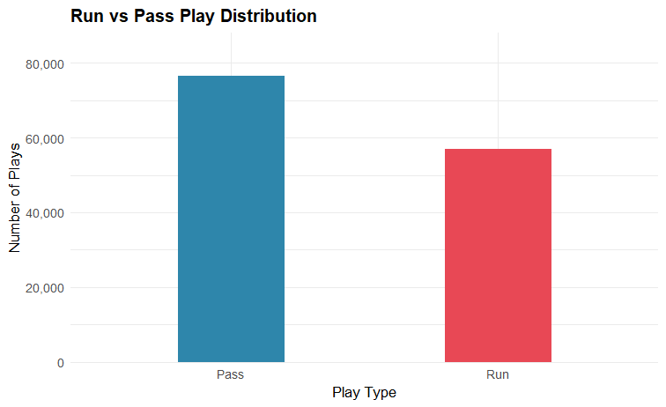
Figure 1: Play Distribution
There is a slight skew towards passing play types that will need to be considered when contextualizing a play prediction with other variables. The pass rate changes by the down as well. Teams are in early-down situations more frequently, as shown by Table 2 in the Appendix. The below plot shows how pass rate changes by the down.
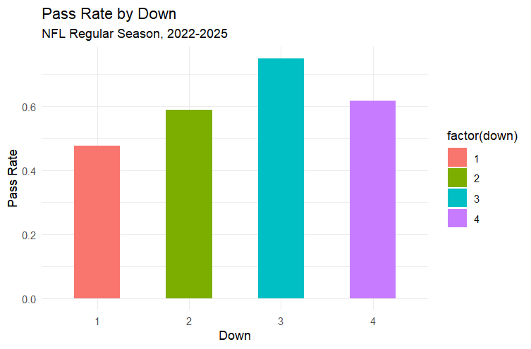
Figure 2: Pass rate by down
Later downs lead to a higher likelihood of passes. Intuitively, this is due to passing the ball being a quicker way to get further downfield, therefore picking up a first down more easily. So, with less chances remaining to pick up a first down, teams will pass more on later downs.
Additionally, the distance a team needs to go for every down impacts pass rates. Below we can see the pass rates from the dataset by down and distance.
Down | Short (1-3 yards) | Medium (4-6 yards) | Long (7-10 yards) | Extra Long (11+ yards)
1 | 28.2% | 34.7% | 47.7% | 67.2%
2 | 35.9% | 49.9% | 65.7% | 77.2%
3 | 47.2% | 85.3% | 88.5% | 84.1%
4 | 46.7% | 90.1% | 91.3% | 90.1%
Table 1: Down and Distance pass rates
A first down is less likely to result in a pass than third and fourth downs, especially when the distance is medium or higher. Down and distance go hand-in-hand with each other and an interaction term would be helpful between the two.
In general, there will be several values of other variables that will fluctuate by pass rate. Examining these scenarios can help contextualize the data and results at the end of the report. The “shotgun” formation tends to indicate a pass more often than not. The bar plot below shows that teams pass out of a shotgun formation nearly 70% of the time.
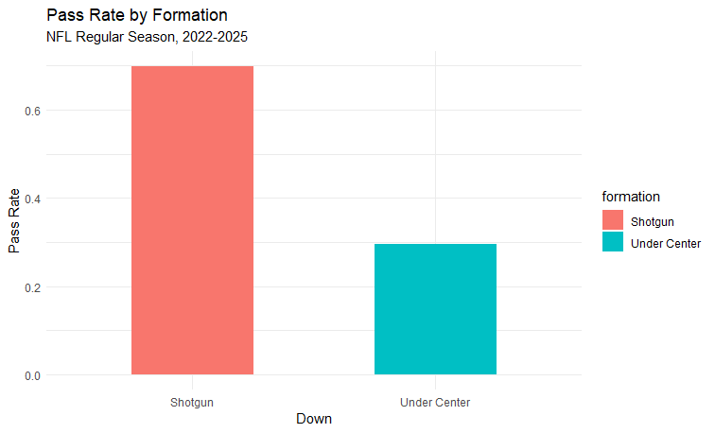
Figure 3: Pass rate by formation
The personnel a team has on the field also impacts if that team is better equipped to run or pass on a given play. For example, 11 personnel (1RB-1TE-3WR) and 22 personnel (2RB-2TE-1WR) show that a team is equipped to do different things, and the 11-personnel pass rate is more than twice that of 22 personnel (Appendix, Table 3).
Ultimately, this dataset has a diverse range of values and metrics to capture what is occurring on a give NFL play. Table 4 in the Appendix shows the summary statistics of each numerical feature. The standard deviations for each numerical feature display a wide range of potential values. For example, the yard line that a play is one can be anywhere from one yard away from the end zone to 99 yards away, displaying a wide range of data to be evaluated.
These variables also show that the data can be correlated. In order to prevent a high amount of multicollinearity from negatively impacting the results, highly correlated variables must be removed. As Table 5 in the Appendix shows, there were several variable pairs that were highly correlated. As a result, the features marking the Number of Seconds Left in the Game, Win Probability, and Number of Wide Receivers were removed from this analysis.

Data Preparation
Additional work on the data was done to create indicator variables, interactions terms, and transform variables as necessary. This is due to the structure of data and creating indicators for scenarios that can impact whether a play is a pass. For example, the “two-minute drill” is when there are less than two minutes left in one of the halves of football, so teams have under two minutes to march down field and score. These scenarios may see more passes, so there is a separate indicator variable for this. There are binary indicator variables for:
- Red zone (when the team is 20 yards or less from the end zone)
- Backed up (when the team is 85 yards or more away from the end zone)
- Two-minute drill (less than two minutes left in the half)
- Leading large (team is up by more than 14 points)
- Trailing large (team is down by more than 14 points)
- Late game (fourth quarter or overtime)
An interaction term was also created for two pairs of variables that interact with one another. Teams passed at a 37% rate on first down and medium (4-6 yards), versus 85% on third down and medium (as shown by Table 1 in the Exploratory Data Analysis section). This indicates Down and Yards to go interact with one another, and an interaction term was created as a result.
Adding in these variables gives us 27 total predictor variables in the data. With creating this interaction term and removing the highly correlated variables from the data, the dataset is ready to be modeled.

Methodology
This report will cover a few data mining strategies for the problem statement and data sources. The dataset first underwent data preparation, where variables intuitive towards predicting an offense’s play were used, then filtered based on highly correlated variables. Interaction terms were added, and this created a final dataset that will go through each of the intended modeling types
First, the data will be split into testing and training sets. The 2022-2024 seasons will be the data the models are trained on while the 2025 season will be the testing set. This will lead to 100,824 plays in the training set and 32,814 in the testing set. The data will also be scaled/standardized prior to entering the model training process.
First, the baseline logistic regression model will be created. This models the log-odds of a play being a pass as a linear combination of all pre-snap features, making it the natural interpretable baseline for a binary classification problem. The model will be fit as a binomial family model within R and will generate predicted probabilities in the [0,1] range. From the results, a positive coefficient means the feature increases pass probability, a negative one decreases it. It is fit here on the full post-data preparation feature set. The baseline logistic regression formula for a pass is as such:
$$P(\text{pass})=\frac{1}{1+e^{-(β_{0}+β_{1}x_{1}+⋯+β_{p}x_{p})}}$$
Next, ridge regression will be conducted. It extends logistic regression by adding an L2 penalty term to the log-likelihood objective, shrinking all coefficients proportionally toward zero without zeroing any of them out. This will help further tackle multicollinearity and prevent overfitting, which the baseline logistic regression model is not as good at accomplishing. The penalty strength lambda is selected by maximizing AUC across five cross-validation folds on the training data.
Then lasso regression will be conducted to extend the logistic regression baseline. Lasso replaces the L2 penalty with an L1 penalty, which has the property of pushing weaker coefficients to zero rather than shrinking them, this creates automatic feature selection as part of the fitting process. This also makes Lasso particularly valuable in this setting because the engineered feature set deliberately may include redundancies between features, so we can let the data determine which is most predictive. The retained non-zero features from Lasso are also used directly to define the input feature set for PCR, creating a pipeline where Lasso's selection informs the dimension reduction step. The lambda value is chosen by 5-fold CV and features with coefficient of 0 are excluded from the final model.
K-Nearest Neighbors is the next model to fit the data on. This is a non-parametric classifier that assigns a play-type label based on the majority vote among the k most similar plays in the training set. Similarity is measured by Euclidean distance in the scaled/standardized dataset. In contrast to the logistic models, it can capture complex interactions between features without requiring them to be specific interaction terms. The drawback is the risk of dimensionality. So, we will choose the best k among the following values: 5, 25, 50, 100, 200. The k will be tuned by AUC on a held-out 10% validation fold of the training data.
Principal Component Regression is the final data mining method to be used. PCR first applies PCA to the consensus feature set identified jointly by both Ridge (top features by coefficient magnitude) and Lasso (non-zero features). A logistic regression is then fit on the top m components rather than the raw features, where m is selected by five-fold cross-validation on the training set to maximize AUC. This gives us a smaller feature set to sort through, with PCR finding the most significant components out of those already determined to be significant from ridge and lasso. If this PCR matches the full-model AUC, that is evidence that play-calling situations rely on less dimensions than those initially tested.
Finally, after these models are constructed, they will be evaluated on multiple metrics. Classification accuracy, sensitivity, specificity, and AUC will be used to evaluate which modeling method is the best.
To extend the classification analysis beyond model performance, we apply the best-performing regression model to each NFL offense individually on the held-out 2025 test season, computing a per-team classification accuracy to determine offensive predictability.

Analysis & Results
The results of each model show which features are significant and how accurate the models are in predicting a play type decision. The first baseline logistic regression model fit all 27 predictor variables and found all but seven predictors to be statistically significant. This sets a baseline of 20 features that are useful in predicting a play type decision to be run or pass.
Ridge regression underwent five-fold cross-validation to find an optimal lambda value. This found a minimum lambda of 0.01827. The ridge model was then fit with this lambda.
Lasso regression also underwent five-fold cross-validation and found a minimum lambda of 0.00174. The lasso model was then fit with this lambda. Five features were zeroed out after running this model – seconds remaining in the half, temperature, the trailing large binary indicator, 21 personnel indicator, and number of tight ends variable. Across the baseline, ridge, and lasso logistic regression models, the shotgun binary indicator had the highest magnitude from all the features.
K-nearest neighbors used a 10% held-out validation set, consisting of 10,082 plays. The below plot shows the AUC of each tested k-value.
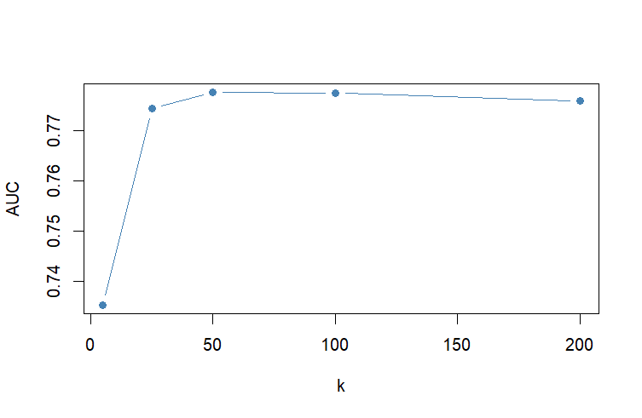
Figure 4: KNN Scree plot
The scree plot shows that a k=50 model leads to the highest AUC, so this will be the k-value used for fitting the KNN model on the testing data.
Lastly, Principal Component Regression used the top 15 coefficients by magnitude from Ridge regression and retained (non-zero) features from Lasso regression. Unioning these, the final feature set contains 22 features, listed in List 1 in the Appendix.
After principal component analysis was done, the results showed that the first component only captured 13.1% of the variance. Cumulatively, it took 12 components to explain 80% of the variance in the data. The defenders in box feature and down x yards to go interaction term explained the most of the first principal component.
The below plot shows the number of components and the cross-validated AUC when fitting a model with n number of components.
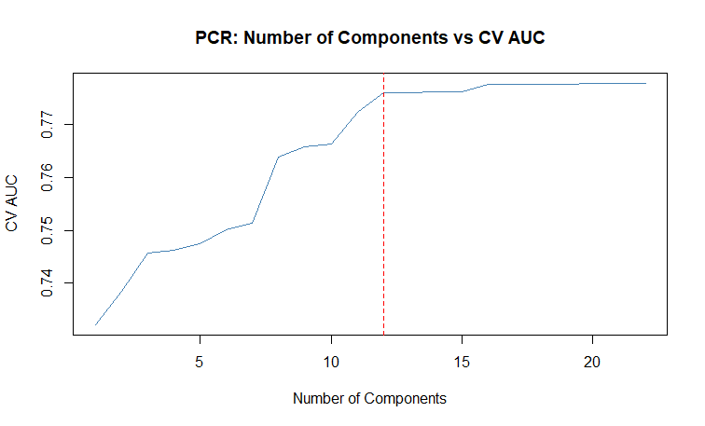
Figure 5: PCA component AUC
We can see that the AUC significantly improves after 5 components and plateaus after 15. 12 components iswhere 80% of variance can be explained and that number also has an AUC of 0.78, so we will use 12 components in our regression. The PCR model was fit using 12 components and the training data, with predictions fit on the testing data for error calculations.
Finally, we can see the comparison between each of these modeling techniques, evaluated on AUC, classification accuracy, sensitivity, and specificity. The below plot shows the AUC for each model.
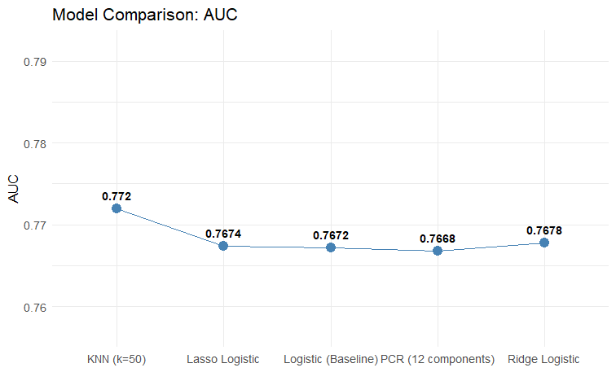
Figure 6: Model AUC comparison
Based on AUC, the KNN model has the best performance but is more difficult to interpret in terms of features that are most significant for predicting play type. As Table 6 in the Appendix shows, the AUC, Accuracy, Sensitivity, and Specificity measures are all close together for each model. The KNN model has the slight edge in AUC performance but other models have the edge in other evaluation metrics. Across all the models, each had a higher Sensitivity than Specificity, indicating the models are more accurate in predicting a pass than in predicting a run.
The Ridge and Lasso models displayed the following coefficients as highest in magnitude when predicting play type:
- Shotgun
- Number of defenders in box
- Down
- Down x yards to go interaction term
- Score differential
Given that Shotgun, Number of defenders in box, and Down x yards to go interaction term were also among the top five features in the first principal component for PCR, we can say these three are the most significant features for predicting play type.
Lastly, running a team predictability exercise using the KNN model showed how accurately the model predicted the play type for each individual team in 2025. As Table 7 in the Appendix shows, the model is most accurate for the Denver, New England, Tampa Bay, and Pittsburgh offenses, while it is least accurate for Washington, Atlanta, and Green Bay. Using a KNN k=50 model, the Broncos are the most predictable team for 2025 pass rates.

Conclusion

Findings
Based on the modeling results, the findings show that a K-nearest-neighbors model with k=50 can predict whether a given play will be a run or pass using only information available before the snap at a 77% accuracy rate. Logistic regression and PCR also work as the accuracy differences between models are miniscule. Since KNN does not offer good interpretability for the impact of features, the PCR, Ridge, and Lasso logistic regression models show the situational metrics that are the most important in predicting whether a play is a run or pass:
- Whether the offense is in Shotgun formation
- The number of defenders the defense has in the box area
- The down and yards to go on that down
- The score differential
Based on Sensitivity and Specificity metrics, we can also see it is more accurate for predicting a pass than a run, though some of this can be attributed to noise due to the fact that plays tend to skew towards the pass more often and the dataset had a 57% pass rate.
Ultimately, these findings can be used for NFL defenses to see what an offense is doing pre-snap, especially with the situational metrics mentioned above. They can run this KNN model before every play to predict what an offense is going to do. An NFL offense can use this analysis to find where they can be less predictable. For example, the Denver Broncos were highly predicable, so defenses can use the pre-snap features used in this analysis to accurately predict what the Broncos are going to do. On the other hand, the Broncos can use this information to add more variability in their pre-snap decisions.

Future Work
Possible future work includes using more data specific to the team or play-caller. A team’s offensive head coach or offensive coordinator makes the play call, so having information on their run/pass tendencies would add more information and context for this data mining exercise. Better data preparation and access to more specific data can improve this analysis.
Besides getting more data, future work can also include exploring other classification modeling techniques for modeling play rate. Time constraints prevented a larger scope of analysis but adding better visualizations using team logos and an R Shiny app to display the team predictability report would be a next step in making this analysis more digestible. Additionally, exploring this question from more angles would be relevant. For example, we can take the grow the scope of this project and ask, what features lead to the most successful pass/run decision in terms of yards gained on that play? Questions like this can help NFL offense add more nuance to decision-making.

Bibliography & Credits
Baldwin, B., Carl, S., Ho, T., & Sharpe, C. (2020). nflfastR: Functions to Efficiently Access NFL Play-by-Play Data. R package. Retrieved from https://nflfastr.com/
nflverse Contributors. (2024). nflverse-data: Play-by-Play Data Releases [Data repository]. GitHub. Retrieved from https://github.com/nflverse/nflverse-data/releases/tag/pbp
Pro Football Focus. (2025). Projecting 2026 Fantasy Volume Through Neutral Situation Pass Rates. PFF Analytics. Retrieved from https://www.pff.com/news/projecting-2026-fantasy-volume-through-neutral-situation-pass-rates
R Core Team. (2024). R: A Language and Environment for Statistical Computing. R Foundation for Statistical Computing, Vienna, Austria. Retrieved from https://www.r-project.org/

Appendix

Down | Number of plays | Pass rate %
1 | 58357 | 47.7%
2 | 44412 | 58.8%
3 | 27694 | 74.9%
4 | 3175 | 61.8%
Table 2: Plays by down

Personnel | Number of plays | Pass Rate
11 (1RB-1TE-3WR) | 80487 | 66.1%
12 (1RB-2TE-2WR) | 27354 | 48.2%
Other | 20225 | 39.6%
21 (2RB-1TE-2WR) | 4401 | 44.8%
22 (2RB-2TE-1WR) | 1171 | 28%
Table 3: Pass rate by personnel

Feature | mean | sd | min | max
down | 1.82 | 0.84 | 1 | 4
ydstogo | 8.45 | 3.97 | 1 | 40
yardline_100 | 50.23 | 24.03 | 1 | 99
score_differential | -1.57 | 10.13 | -56 | 50
wp (win probability) | 0.5 | 0.29 | 0 | 1
game_seconds_remaining | 1731.99 | 1047.15 | 0 | 3600
temp | 60.39 | 13.54 | 6 | 93
wind | 4.44 | 5.32 | 0 | 44
defenders_in_box | 6.23 | 1.01 | 0 | 11
Table 4: Summary stats for numerical features

Feature 1 | Feature 2 | Correlation
Play ID | Seconds remaining in game | -0.985
Seconds remaining in game | Quarter | -0.964
Play ID | Quarter | 0.958
Score differential | Win probability | 0.919
Number of WRs | 11 personnel indicator | 0.827
Number of WRs | Number of TEs | -0.816
Table 5: Highly-correlated variables

Model | Accuracy | AUC | Sensitivity | Specificity
Logistic | 0.7132 | 0.7672 | 0.797 | 0.603
Ridge | 0.7127 | 0.7678 | 0.7992 | 0.5987
Lasso | 0.7117 | 0.7674 | 0.7989 | 0.5969
KNN (k=50) | 0.7111 | 0.772 | 0.774 | 0.6283
PCR (12 components) | 0.7132 | 0.7668 | 0.7998 | 0.5992
Table 6: Model Evaluation table
 | Team | 2025 # plays | Actual Pass Rate | Accuracy | AUC
1 | ARI | 1070 | 0.661 | 0.719 | 0.737
2 | NO | 1061 | 0.598 | 0.71 | 0.792
3 | BUF | 1056 | 0.506 | 0.745 | 0.8
4 | BAL | 954 | 0.486 | 0.717 | 0.783
5 | JAX | 1070 | 0.562 | 0.727 | 0.766
6 | CAR | 991 | 0.553 | 0.723 | 0.792
7 | CIN | 1044 | 0.645 | 0.739 | 0.755
8 | CLE | 1024 | 0.593 | 0.751 | 0.803
9 | DAL | 1101 | 0.592 | 0.718 | 0.765
10 | PHI | 992 | 0.534 | 0.67 | 0.734
11 | GB | 991 | 0.522 | 0.65 | 0.728
12 | DET | 1050 | 0.59 | 0.749 | 0.787
13 | HOU | 1072 | 0.569 | 0.744 | 0.789
14 | LA | 1056 | 0.584 | 0.692 | 0.725
15 | KC | 1045 | 0.601 | 0.705 | 0.782
16 | LAC | 1079 | 0.579 | 0.717 | 0.779
17 | LV | 939 | 0.613 | 0.735 | 0.758
18 | NE | 1014 | 0.542 | 0.755 | 0.804
19 | IND | 1004 | 0.572 | 0.68 | 0.747
20 | MIA | 939 | 0.548 | 0.685 | 0.768
21 | MIN | 939 | 0.578 | 0.741 | 0.775
22 | CHI | 1090 | 0.547 | 0.706 | 0.751
23 | WAS | 972 | 0.514 | 0.609 | 0.729
24 | NYG | 1075 | 0.533 | 0.662 | 0.748
25 | NYJ | 1001 | 0.55 | 0.668 | 0.745
26 | PIT | 974 | 0.594 | 0.751 | 0.821
27 | SEA | 994 | 0.507 | 0.684 | 0.718
28 | SF | 1060 | 0.564 | 0.731 | 0.775
29 | ATL | 1032 | 0.55 | 0.63 | 0.751
30 | TB | 1057 | 0.563 | 0.753 | 0.801
31 | TEN | 995 | 0.626 | 0.741 | 0.785
32 | DEN | 1073 | 0.592 | 0.757 | 0.8
Table 7: Team predictability
Down, yards to go, yards team is from endzone, score differential, shotgun indicator, no huddle indicator, number of timeouts remaining for both the possessing and defensive teams, goal to go indicator, dome indicator, wind speed, redzone indicator, backed up indicator, two minute drill indicator, leading large indicator, late game indicator, indicators for 11 personnel, 12 personnel, and 22 personnel, number of running backs, number of defenders in the box, and the down x yards to go interaction term.
List 1: PCR Feature Set

